*Nix

Local user information is stored in the /etc/passwd file. Each line in this file represents login information for one user. **To open the file you can use the command as follows**, cat /etc/passwd:

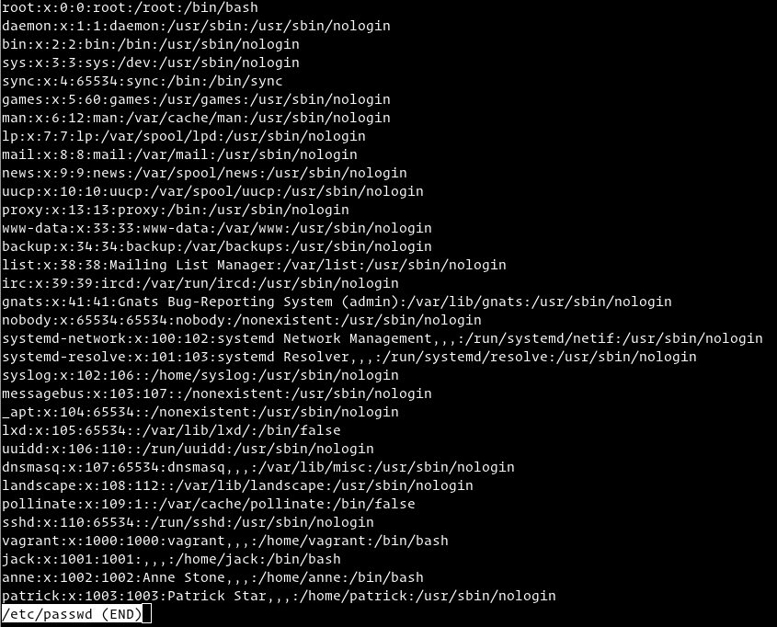

As you can see from the output above, each line has seven fields delimited by colons that contain the following information:

* User name
* Encrypted password (x means that the password is stored in the /etc/shadow file)
* User ID number (UID)
* User’s group ID number (GID)
* Full name of the user
* User home directory
* Login shell (defaults to /bin/bash)

**Side Note:** If you want to display only the username you can use either awk or cut commands to print only the first field containing the username:

awk -F: '{ print $1}' /etc/passwd

cut -d: -f1 /etc/passwd

Changing user passwords

To change a user’s password, you’ll be using the “passwd” command.

**Example command:** passwd <user name>

**Example output:**

Enter new UNIX password:

Retype new UNIX password:

passwd: password updated successfully

Windows

**A list of local users can be found using the command** net user:

C:\Users\chuus>net user

User accounts for \\LAPTOP-JTQUUHD6

-------------------------------------------------------------------------------

Administrator chuus Claire

DefaultAccount Guest WDAGUtilityAccount

The command completed successfully.

The net user command allows for you to interact in different ways with the system users, whether that be deleting a user, adding a user, or changing a user password. Typing net help user will guide you in engaging with your system user accounts.